# Basic Electronic Components

Written by Mark Webster, Connor Sheeran, Ousema Zayati

**Summary**:

Learn to identify and know the primary features of the common electronics components.

All electronic devices are built from basic components, just as all chemicals are molecules made from a few basic atoms.

## What are the basic components

(batteries, resistors, capacitors, inductors, switches, buttons, diodes, LED, transistor, IC)

<https://en.wikipedia.org/wiki/Electronic_component>

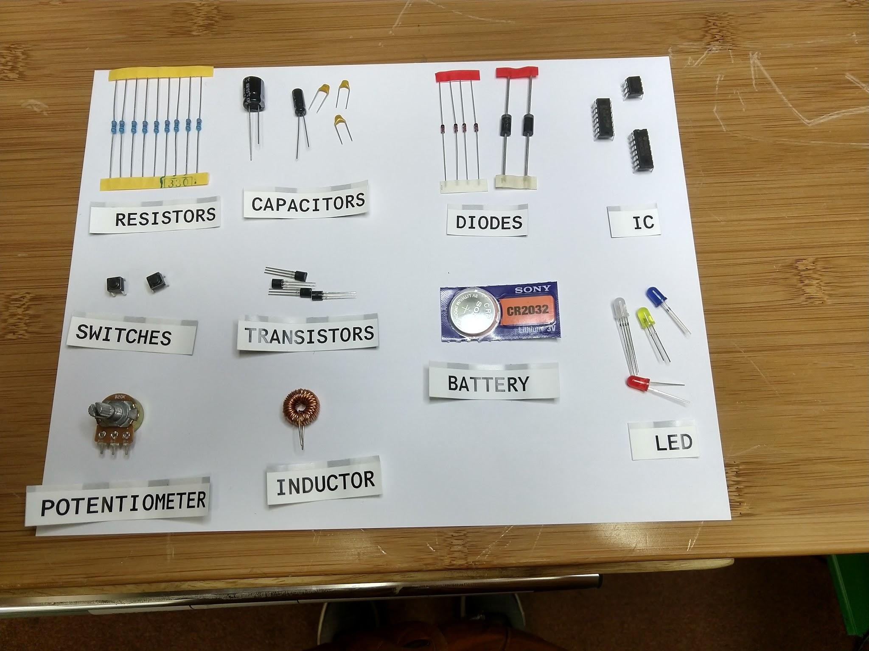

The flow of electrons in a circuit can be related to the flow of water molecules through plumbing. Wires are like pipes that channel water or electrons into a directed flow. Resistors are like a constriction in the pipe that resists water flow. Buttons and switches are like valves that permit or stop the flow of water. Capacitors and inductors are like little storage tanks that hold charge. Diodes, including LEDs or light emitting diodes, are one way valves that force water to go only one way. Transistors are special valves where a small turn of the valve wheel causes a big change in the flow of water.

Resistors can be fixed or variable resistance. The resistance of a potentiometer can be manually varied. Many sensors are fancy variable resistors. For example, a photoresistor changes resistance based on the intensity of light shining on the device.

Voltage (V or E) is like water pressure. Amperage (I) is the quantity of water flowing through the pipes.

Voltage and amperage are related by Ohm’s law: , where V is in volts, I is current in amps, and R is resistance in ohms. Electronic Engineers write

## How to read a schematic

A schematic diagrams an electronic circuit using standard symbols, with lines representing wires or pc board traces. There are some variations of standard symbols. <https://en.wikipedia.org/wiki/Electronic_symbol>

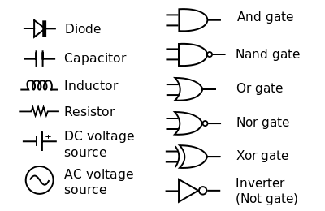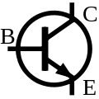Transistor

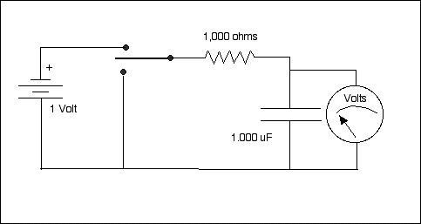

Image From Wikimedia Commons

## How to read a datasheet

<https://learn.adafruit.com/all-about-leds/the-led-datasheet>

<https://www.sparkfun.com/datasheets/Components/YSL-R596CR3G4B5C-C10.pdf>

<http://www.ti.com/lit/ds/symlink/lm555.pdf>

## Tools: multi-meter, oscilloscope, bench top power supply

A multimeter measures voltage, current, resistance. Some meters will also measure capacitance and inductance.

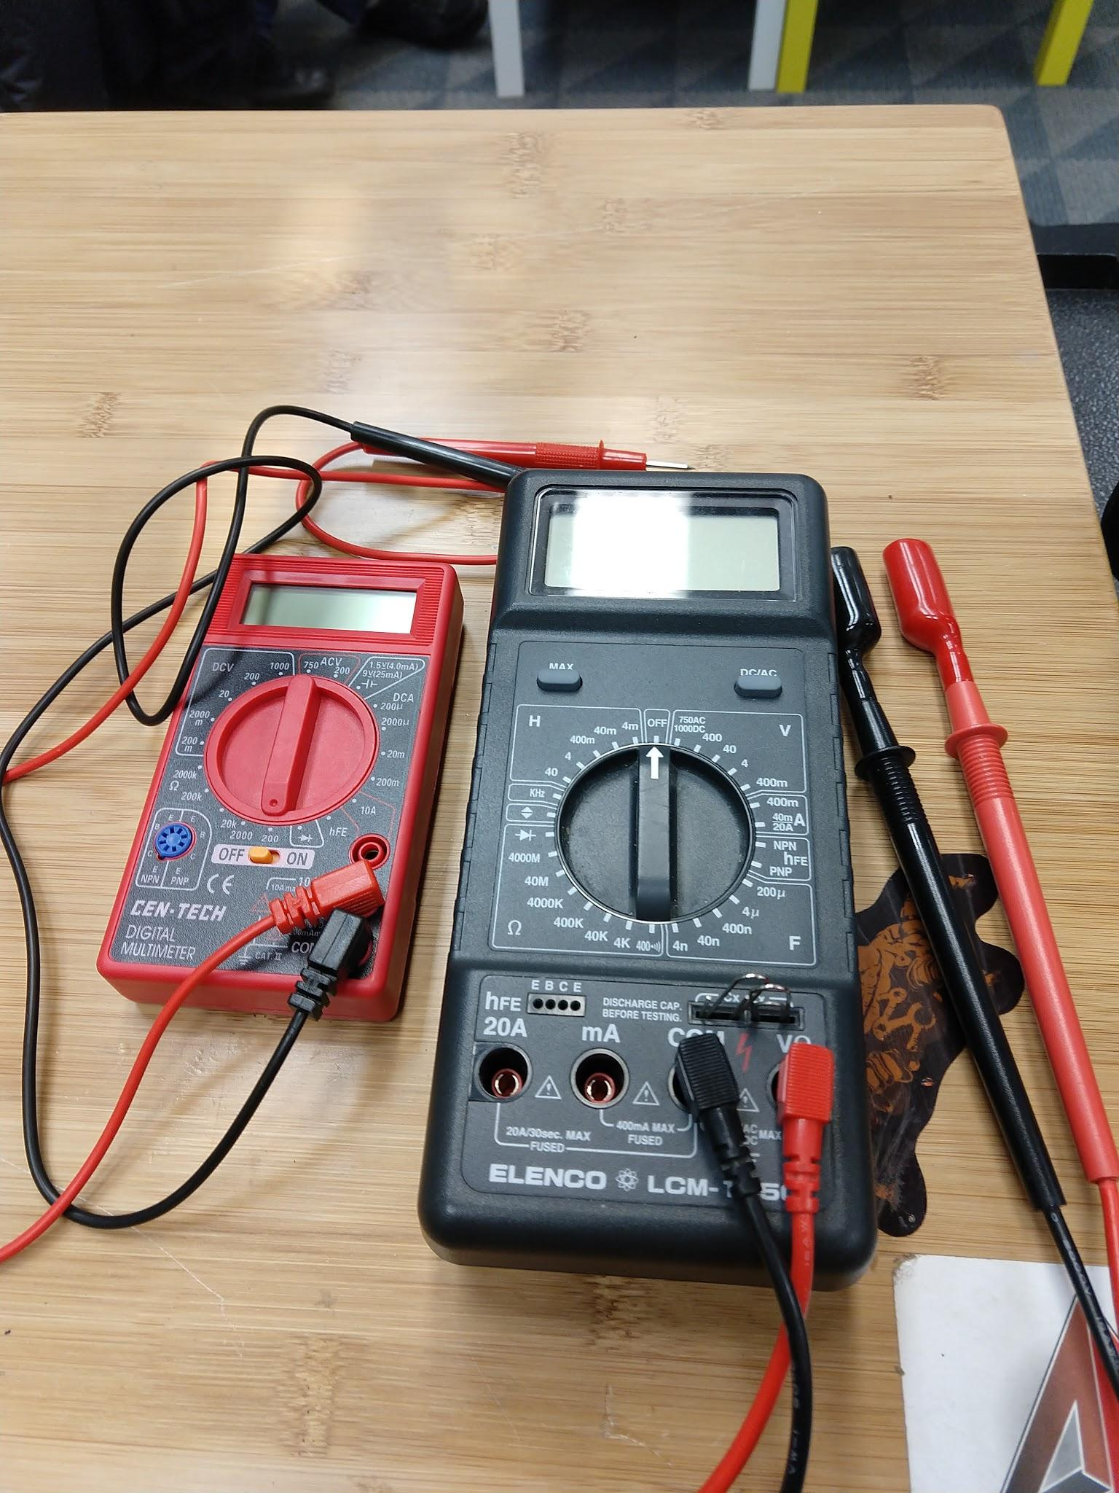

An oscilloscope is used to examine AC voltage; a signal that varies with time. (take photo)

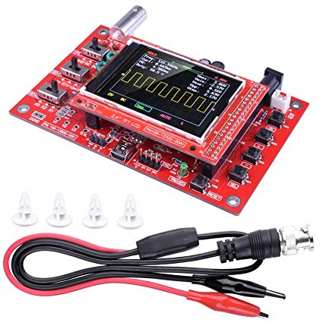

## How to breadboard a circuit

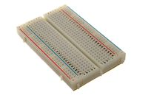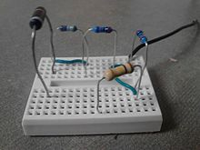

## EXERCISES

### Exercise 1: Read a resistor color code

Grab a random resistor and figure out the resistance from the color bands on the resistor.

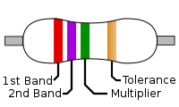

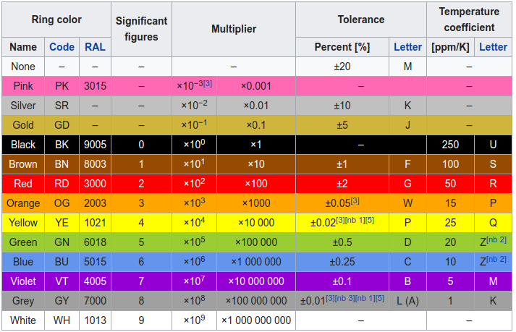

For example,

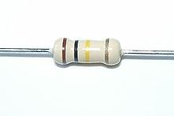is 100K ohms with a tolerance of 10 percent.

Then measure the actual resistance with a multimeter and verify it is within tolerance.

Capacitors have a color code, but usually they are just marked with numbers.

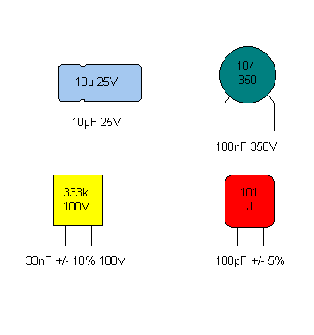

Larger value capacitors are often polarized and must be inserted into the circuit with one lead toward the positive, and one lead toward ground.

Just like LEDs and diodes, the short leg is the negative (toward ground) and the positive side is the long leg. Many electrolytic capacitors have + and - marked on the case.

Grab a capacitor and measure the capacitance using a meter.

### Exercise 2: LED and potentiometer

-- Battery, potentiometer, resistor, LED to have variable intensity light

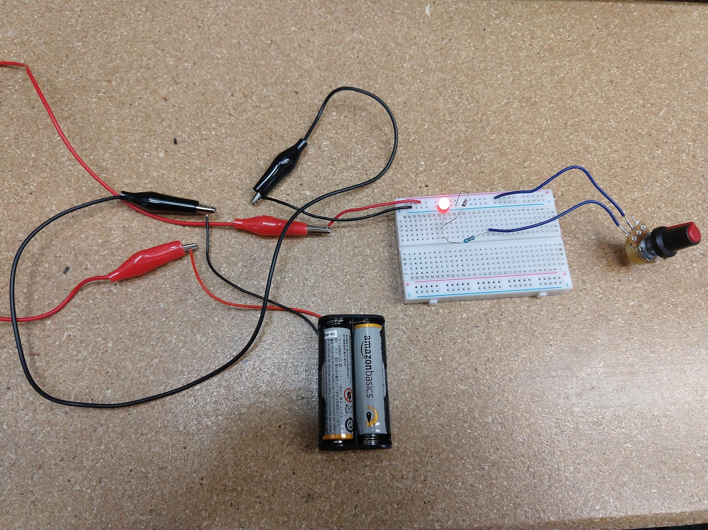

### Exercise 3: 555 timer circuit

-- 555 timer circuit

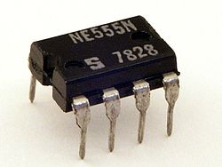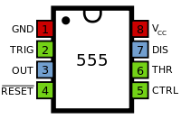

A 555 timer chip can be used to create one pulse of electricity after some interval, or can be made to oscillate and give repeated pulses.

Typical datasheet specs are:

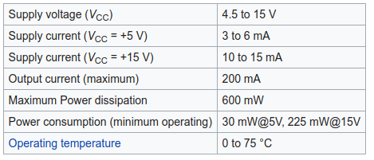

A schematic for the oscillator (astable) circuit is:

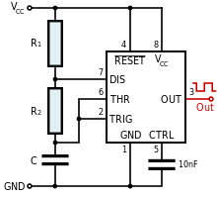The frequency f of the pulses is 

As a first attempt, use C = 480 microfarad, R1 = R2 = 1k ohms.

The frequency of blinking should be around 1 hz.

A fritzing diagram for the oscillator (astable) might be:

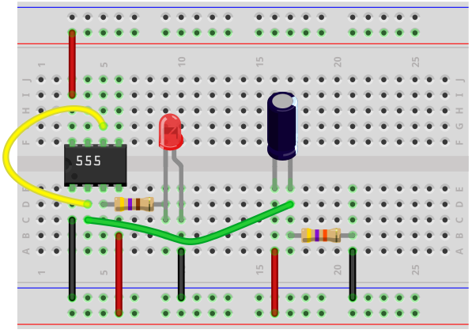

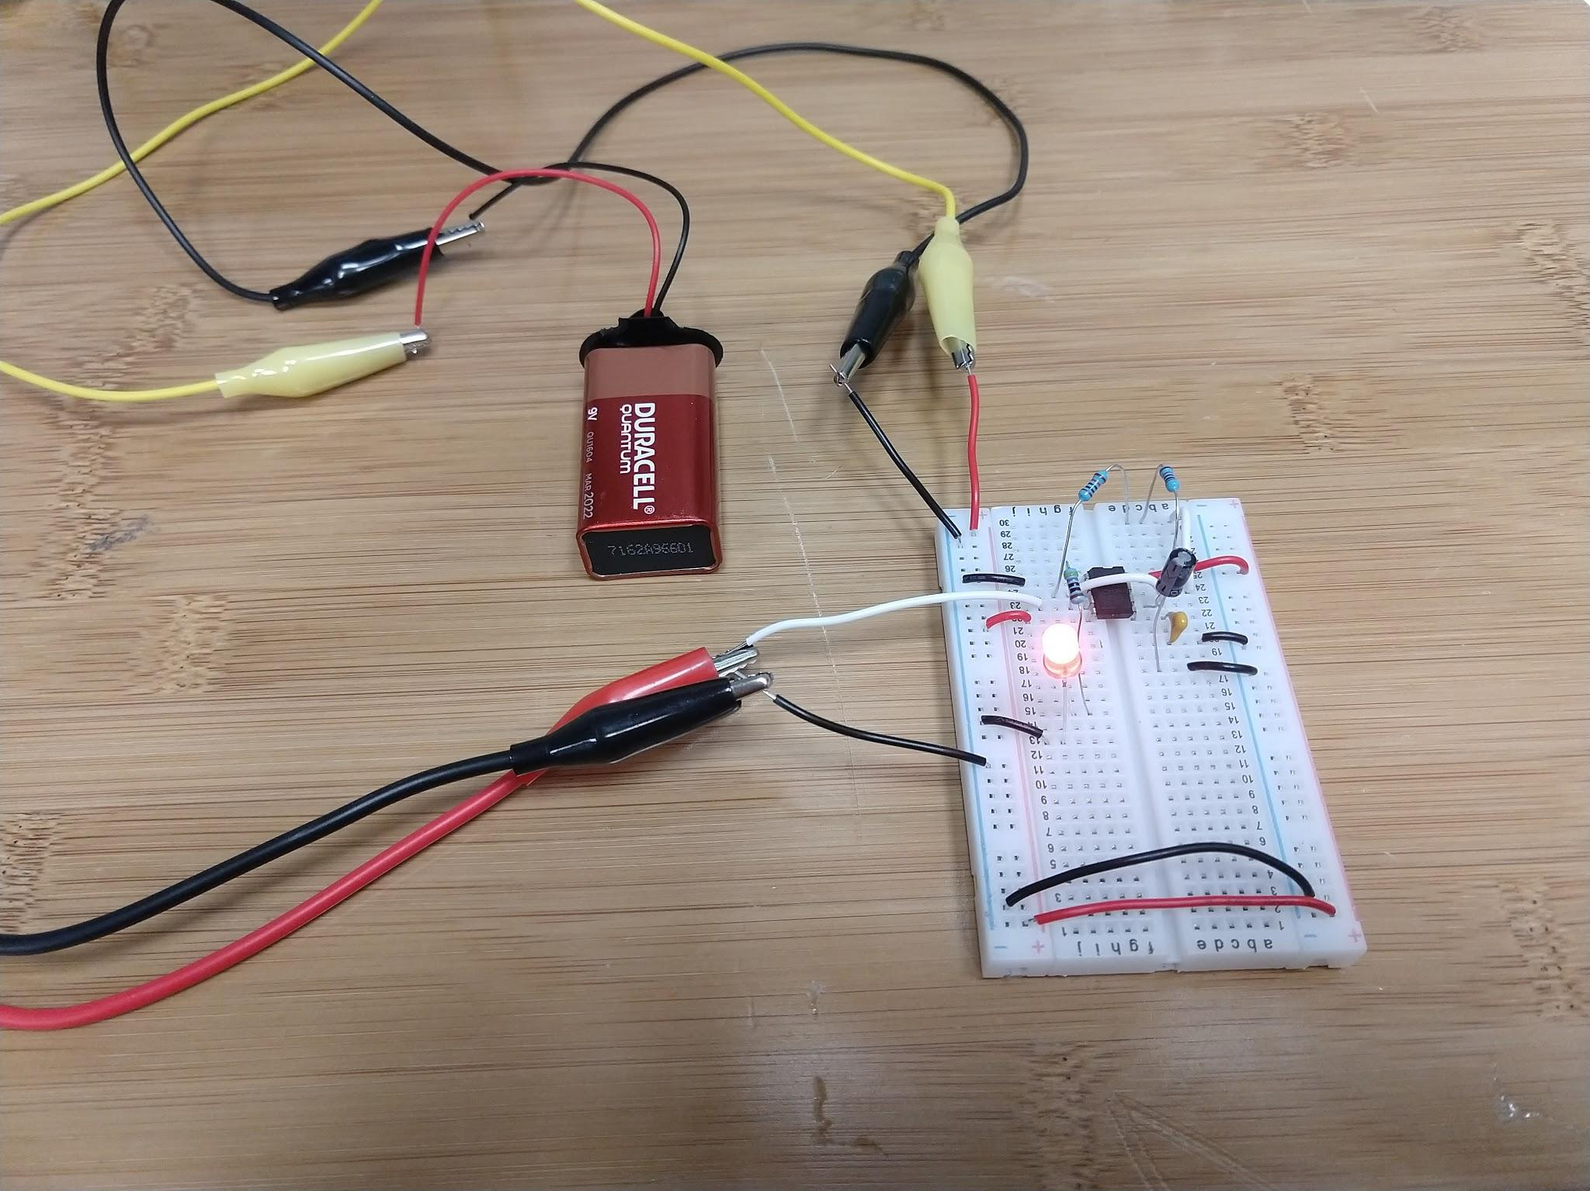

If timer permits, solder the 555 timastable timer circuit to a perf board.